MODULE-7 (7.2)

# 1.QUESTION

**PROGRAM CODE:**

package hey;

import java.util.Scanner;

public class Fish

{

public String typeOfFish;

public int friendliness;

}

# 2 QUESTION

PROGRAM CODE:

public class Fish {

public String typeOfFish;

public int friendliness;

public Fish() {

typeOfFish = "Unknown";

friendliness = 3;

}

}

# 3 QUESTION

PROGRAM CODE:

public class Fish {

public String typeOfFish;

public int friendliness;

public Fish() {

typeOfFish = "Unknown";

friendliness = 3;

}

public Fish(String t, int f) {

typeOfFish = t;

friendliness = f;

}

}

# 4 QUESTION

PROGRAM CODE:

public class Fish {

public String typeOfFish;

public int friendliness;

public Fish() {

typeOfFish = "Unknown";

friendliness = 3;

}

public Fish(String t, int f) {

typeOfFish = t;

friendliness = f;

}

public int getFriendliness() {

return friendliness;

}

}

# 5 QUESTION

PROGRAM CODE:

public class Fish {

public String typeOfFish;

public int friendliness;

public Fish() {

typeOfFish = "Unknown";

friendliness = 3;

}

public Fish(String t, int f) {

typeOfFish = t;

friendliness = f;

}

public int getFriendliness() {

return friendliness;

}

public static Fish nicestFish(Fish fish1, Fish fish2) {

if (fish1.getFriendliness() > fish2.getFriendliness()) {

return fish1;

} else {

return fish2;

}

}

public static void main(String[] args) {

Fish fish1 = new Fish("Goldfish", 4);

Fish fish2 = new Fish("Piranha", 2);

Fish nicest = Fish.nicestFish(fish1, fish2);

System.out.println("The fish with the higher friendliness is: " + nicest.typeOfFish);

}

}

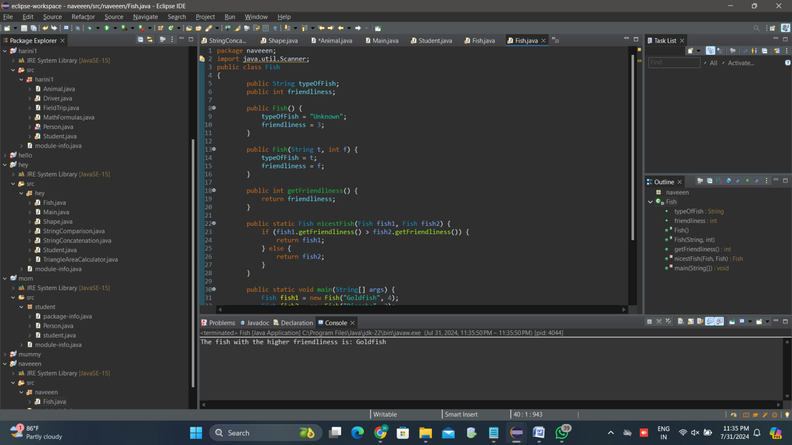

# 6 QUESTION

PROGRAM CODE:

public class Fish {

public String typeOfFish;

public int friendliness;

public Fish() {

typeOfFish = "Unknown";

friendliness = 3;

}

public Fish(String t, int f) {

typeOfFish = t;

friendliness = f;

}

public int getFriendliness() {

return friendliness;

}

public static Fish nicestFish(Fish... fishArray) {

if (fishArray.length == 0) {

return null;

}

Fish temp = fishArray[0];

for (Fish fish : fishArray) {

if (fish.getFriendliness() > temp.getFriendliness()) {

temp = fish;

}

}

return temp;

}

public static void main(String[] args) {

Fish fish1 = new Fish("Goldfish", 4);

Fish fish2 = new Fish("Piranha", 2);

Fish fish3 = new Fish("Clownfish", 5);

Fish nicest = Fish.nicestFish(fish1, fish2, fish3);

System.out.println("The fish with the highest friendliness is: " + nicest.typeOfFish);

}

}

